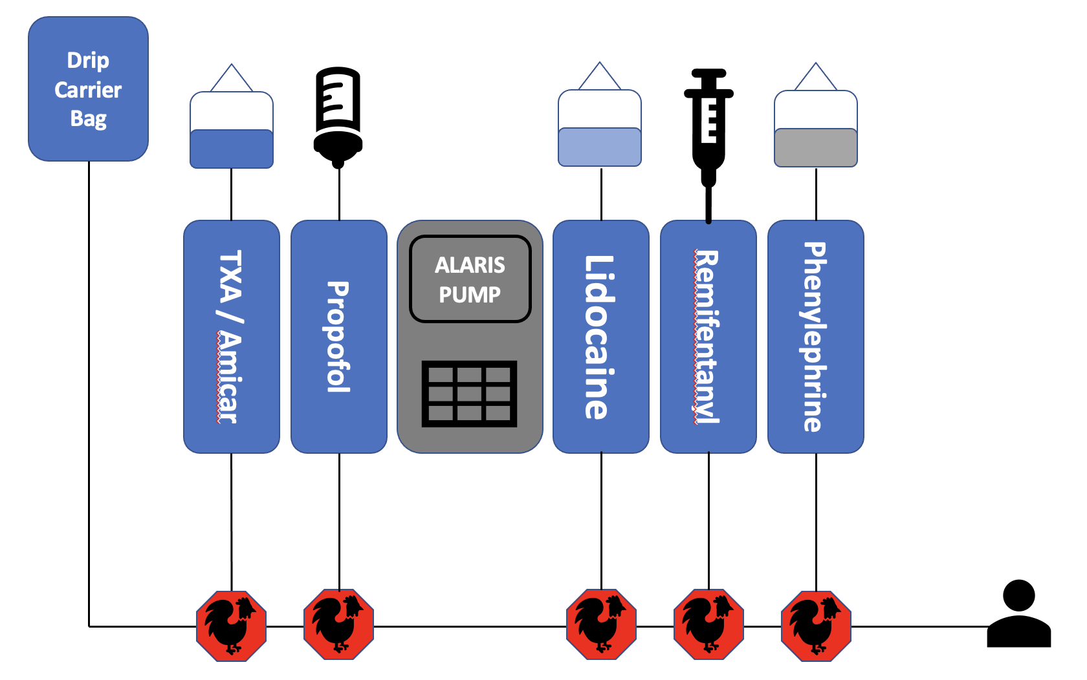Definition

***Scoliosis***

Scoliosis is defined as curvature of the spine in the coronal plane greater than 10 degrees (as measured by the Cobb angle). Idiopathic scoliosis is scoliosis with no definite etiology. Adolescent idiopathic scoliosis (AIS) is scoliosis that presents in a patient at age 10 or older and accounts for 80-85 percent of scoliosis cases.

***Scoliosis surgical correction***

Treatment modalities for scoliosis include observation, bracing, and surgery.

Surgical correction is indicated for skeletally immature and mature patients with curves with a Cobb angle greater than or equal to 50 degrees. Skeletally mature patients with curves between 40 and 50 degrees are managed by a provider on an individual basis.

Surgical treatment of AIS is done by a spinal fusion procedure. Spinal fusions can be done posteriorly or anteriorly; posterior spinal fusion with instrumentation and bone grafting is the most common surgical procedure for AIS correction. The primary surgical treatment goal for AIS is prevention of curve progression and the secondary goal is improved quality of life, including enhanced patient reported self-image, function, and level of activity.

Common barriers in the immediate postoperative period for spinal fusion patients include delayed mobilization, delayed return of bowel function, pain management, opioid use side effects, and prolonged hospitalization. The literature supports the use of a rapid recovery pathway for AIS spinal fusion patients that focuses on early mobilization, early initiation of a bowel regimen, early transition from intravenous opioid pain management to oral opioid and non-opioid analgesic pain management, and multimodal pain regimens to mitigate common postoperative barriers to full functional recovery.

Epidemiology

The prevalence of AIS is approximately 1 to 3 percent; only 0.3 percent of the AIS population require treatment. Males and females are affected equally, but the risk of curve progression is 10 times higher in females. Overweight or obese patients seem to have increased severity of AIS on initial presentation, possibly due to delayed detection.

Between the years 2001 to 2011, an average of 5,000 AIS spinal fusions were performed annually in North America.

Etiology

There is no clear etiology of AIS. Literature supports a potential genetic component. There is also research that proposes abnormalities in growth hormone secretion, connective tissue structure, paraspinal musculature, vestibular function, melatonin secretion, and platelet microstructure may contribute to the pathogenesis of AIS.

Anesthesia consultation checklist preoperative appointment:

1. Education given to family at pre-admission testing appointment:
   * Discuss plan and associated risks including: Endotracheal tube (ETT), Total intravenous anesthesia (TIVA), IVs, possible need for a central access, arterial line, pain management, wake up test, risk of vision loss, potential need for blood transfusion, post-op facial swelling, and pressure points.
   * Give time of arrival for surgery and where to check in
   * NPO instructions
   * Instruct patient to drink 10-12 oz of clear carbohydrate drink 2 hours prior to arrival.
   * Bathing protocol- Per Physician Preference.
   * Verify Procrit (epoetin alfa) regimen if ordered by the surgical service.
2. Pre-operative Anesthesia Labs:

Type & Screen, CBC, coagulation studies (INR, PT, PTT)  
Pregnancy Test, COVID 19 test as per protocol.

1. Order appropriate medications at pre-admission testing appointment, including:
   * Premeds for anxiety as indicated.
   * Order **Gabapentin** to be given at the day of surgery- 600 mg for patients weighing > 50 kg or 10 mg/kg/dose for patients <50 kg.
   * IV **Methadone** should be considered if intrathecal morphine is not an option. Methadone tabs are available in the preoperative pyxis, liquid formulation available via pharmacy.
   * **Anti-emetic**: if high risk for PONV, you may consider **Emend** and placing a **Scopolamine** patch (1mg) behind the ear in preop area. It should remain on the patient for 72 hours. Patch should be placed on a case-by-case basis only
2. Preadmissions Nursing
   * Obtain weight and height and record in the EMR
   * Draw ordered lab work. Send for diagnostic testing if indicated.
   * Arrange for EKG if ordered
   * Sign and witness surgical and anesthesia consent

**INTRA OPERATIVE MANAGEMENT:**

*General guidelines*:

Goal directed fluid management is the guiding principle for perioperative management. This paradigm consists of:

* Attempt to restrict crystalloid infusions to < 5ml/kg/hr.
* Giving fluid volume as dictated by increasing base deficits, pulse pressure variation, or lactates.
* Colloid or blood (check Hgb) for volume replacement when indicated by objective measures.
* Periodic assessment (every 1-2 hours) of global perfusion: ABG, Hgb.
* Deliberate hypotension if appropriate. Aim for a mean blood pressure no less than 20 percent below baseline, and no less than 60 – 65 mmHg during periods of potential spinal cord compromise/ manipulation.

*Blood Utilization:*

* Intraoperative maintenance of hemoglobin level of at least 7-8 g/dl throughout surgical procedure, with adjustments as the clinical situation dictates.
* Utilization of Amicar/TXA to minimize blood loss.
* Use of autologous blood products, if available, to address oxygen delivery concerns and avoid excessive crystalloid infusions to support intravascular volume.
* Cell Saver
* Acute Isovolemic Hemodilution <!-->link<--!>

Anesthetic management must adequately perfuse a spinal cord at risk for ischemic insults, while permitting effective nervous system monitoring and minimizing blood loss. The surgeon and anesthesiologist should address specific risks for spinal cord ischemia in a patient with more advanced disease. In such cases, maintaining adequate cord perfusion takes precedence.

Addressing possible blood loss during these procedures must be balanced with minimizing exposure to allogeneic blood products. Maintaining hemoglobin levels above 7-8 mg/dl for most patients is sufficient. More aggressive transfusions may be indicated for patients with increased risk for ischemic damage.

Inadequate global perfusion may be evidenced by:

* arterial blood pressure respiratory variation,
* increasing base deficit with anion gap
* increasing lactate levels, or
* changes in neural monitoring signals.

These should be addressed expeditiously to increase global oxygen delivery.

Deliberate hypotension can reduce intraoperative blood loss, but concerns regarding spinal cord perfusion and reports of postoperative visual loss have discouraged the practice. While length of surgery and large intraoperative blood loss are major risk factors most associated with visual complications to date, aggressive hypotensive techniques are coming under increasing scrutiny. The use of anti-fibrinolytic agents can significantly diminish blood loss during surgery at acceptable risk. These agents should especially be considered for children with a neuromuscular etiology for their scoliosis, or when procedures are expected to be difficult and prolonged.

Equipment checklist – The following should be ready and in the room

1. Appropriate airway device
2. Invasive monitoring
3. Spinal kit with preservative-free morphine
4. Hemodilution bags x2

1) Anesthesia Techniques

A) **Option 1: Intrathecal Morphine** (5-10mcg/kg - 0.5 mg MAX) + **Remifentanil** (0.05-0.4mcg/kg/min).

(If spinal placement is challenging, have surgeon place spinal or IV methadone).

B) **Option 2**: **IV Methadone** 0.2mg/kg + **Remifentanil** (0.05-0.4mcg/kg/min).

2) Anti-Fibrinolytic

**Amicar-**Load: 100 mg/kg over 30 minutes (max 5 g). Maintenance infusion at 30 mg/kg/hour, continue until skin closure.

**TXA-** Load: 50 mg/kg over 30 minutes (max 5 g). Maintenance infusion at 5 mg/kg/hour, continue until skin closure.

3) **Antibiotics: Cefazolin** 25mg/kg, (max 2 g) – Re-dose q4h.

If allergies: Clindamycin 10mg/kg (Max 900mg). Re-dose q6h **or** Vancomycin 10mg/kg (Max 1g) Re-dose q6h.

4) Other Medications

* 1. Dexamethasone: 4mg.
  2. Ondansetron: 4mg
  3. **Diazepam** IV 0.05 mg/kg **or Methocarbamol (Robaxin)**: 15mg/kg IV **after** emergence to treat muscle spasms

5)  **Neuromonitoring:** MEP/SSEPs/EMGs typically monitored. **Place bilateral soft bite blocks!!!**

6) Minimal to no paralysis on intubation. No nitrous. Max 0.5 MAC inhalation agent – Sevoflurane for rapid emergence.

7) POSTOP ORDERS BEFORE LEAVING OR:

A)  Demand only PCA

B)  If no IT morphine given: Methadone 0.1mg/kg IV/PO x 2 q6h, timed 6 hours after initial dosing.

C)  Contact the acute pain team add the patient to pain list.

**Post-op pain management**

|  |  |  |  |  |  |  |
| --- | --- | --- | --- | --- | --- | --- |
|  | **PCA** | **Diazepam** | **Acetaminophen** | **NSAIDs** | **Gabapentin** | **Oxycodone** |
| **POD 0** | **Demand only** | **PO/IV q8h** | **IV q6h ATC x 24h** | **Alternate with acetaminophen.** | **PO TID ATC** |  |
| **POD 1** | **Demand only** | **POq8h PRN** | **PO/IV PRN** | **Ibuprofen q6h ATC.** | **PO TID ATC** | **Q6h ATC** |
| **POD 2** | **D/C consider PRN opioids** | **POq8h PRN** | **PO PRN** | **Ibuprofen q6h ATC.** | **PO TID ATC** | **ATC** |
| **POD 3** | **PRN opioids** | **POq8h PRN** | **PO PRN** | **Ibuprofen q6h ATC.** | **PO TID ATC** | **ATC** |

Diazepam 0.05-0.1mg/kg/dose IV/PO (prn may be switched to ATC postop)  
Alternative to diazepam--Methocarbamol: 15mg/kg IV prn x1 (PACU only), 10mg/kg PO q6h prn Acetaminophen 10-15mg/kg/dose IV or PO (i.e. MN-6AM-12PM-6PM)  
Ketorolac 0.5mg/kg/dose (i.e. 3PM-9PM-3AM)  
Ibuprofen 5-10mg/kg/dose (i.e. 9A-3P-9P-etc)  
Oxycodone 0.05-0.15mg/kg dose (Tramadol 1-1.5mg/kg/dose as alternative)  
Nalbuphine 0.05-0.1mg/kg/dose IV q3h prn for pruritus (central opioid)  
Gabapentin dosing: >50 kg 200mg TID, <50 kg5mg/kg TID. Stop at discharge. No home prescription or wean necessary unless rare exception.

**Postoperative anti-emetic medication**

Ondansetron 0.1mg/kg IV/PO q8h prn postop, max 8mg/dose  
Scopolamine patch: maintenance of patch for 72 hours, if patch placed in OR or if patient exhibits severe PONV in recovery area may consider placement of patch in recovery area  
Promethazine 0.25mg/kg IM q6h prn postop, max 25mg